

MSc Data Science Project
7PAM2002
Department of Physics, Astronomy and Mathematics

Data Science FINAL PROJECT REPORT

Project Title:
Cost-Aware, Calibrated, and Explainable Prediction of Credit Card Default

Student Name and SRN:
Durga Prasad Rao Mannem, 23072455

Supervisor: DR. Vandana Das
Date Submitted: 06-01-2026
Word Count: 4854
Github Link: https://github.com/Durga-DS1566/Datascience-project.git

DECLARATION STATEMENT

This report is submitted in partial fulfilment of the requirement for the degree of Master of Science in Data Science at the University of Hertfordshire.
I have read the detailed guidance to students on academic integrity, misconduct and plagiarism information at Assessment Offences and Academic Misconduct and understand the University process of dealing with suspected cases of academic misconduct and the possible penalties, which could include failing the project or course.
I certify that the work submitted is my own and that any material derived or quoted from published or unpublished work of other persons has been duly acknowledged. (Ref. UPR AS/C/6.1, section 7 and UPR AS/C/5, section 3.6)
I did not use human participants in my MSc Project.

I hereby give permission for the report to be made available on module websites provided the source is acknowledged.

Student Name printed: Durga Prasad Rao Mannem

Student Name signature: Durga Prasad

Student SRN number: 23072455

UNIVERSITY OF HERTFORDSHIRE
SCHOOL OF PHYSICS, ENGINEERING AND COMPUTER SCIENCE

ACKNOWLEDGEMENT

I would like to express my sincere gratitude to my supervisor, Dr. Vandana Das, for their guidance, constructive feedback, and patience throughout this project. I am also grateful to the Data Science teaching team and lab staff for creating a supportive learning environment, and to my classmates for their discussion, code reviews, and encouragement.
This work uses the UCI Machine Learning Repository “Default of Credit Card Clients” dataset; I acknowledge Yeh and Lien for compiling and sharing the data, and the UCI team for maintaining open access resources. The project relied heavily on the open-source Python ecosystem—especially NumPy, pandas, scikit-learn, XGBoost, Matplotlib, and SHAP—and I thank the maintainers and contributors of these libraries. I also appreciate the availability of Google Colab for enabling a reproducible workflow.
Finally, heartfelt thanks to my friends for their constant support and motivation during my MSc studies.

ABSTRACT

Credit card default prediction is a critical task in financial risk management, where inaccurate decisions can lead to significant financial losses. This project investigates the use of machine learning and deep learning techniques to predict credit card default using an imbalanced real-world dataset containing customer demographic information, repayment history, billing amounts, and payment records.
A baseline Logistic Regression model was developed and compared with an advanced gradient boosting model (XGBoost) and a recurrent neural network based on a Gated Recurrent Unit (GRU) architecture. Model performance was evaluated using imbalance-aware metrics, with particular emphasis on Precision–Recall AUC (PR-AUC). The XGBoost model achieved a higher PR-AUC (≈ 0.554) compared to the baseline Logistic Regression model (≈ 0.5), indicating improved identification of high-risk customers.
To support operational decision-making, probability calibration was applied using isotonic regression, resulting in a reduction in calibration error as measured by the Brier score (≈ 0.1355). A cost-sensitive decision threshold, based on a false-negative–to–false-positive cost ratio of 5:1, further reduced the expected decision cost compared to a fixed threshold strategy.
Model explainability was addressed using SHAP, which identified repayment history and billing-related variables as the dominant drivers of default risk at both global and individual levels. Overall, the results demonstrate that integrating predictive modelling with calibration, cost-aware decision policies, and explainability leads to a robust and practically usable framework for credit card default prediction.

TABLE OF CONTENTS
CHAPTER NO | TITLE | PAGE NO
 | DECLARATION STATEMENT  ACKNOWLEDGEMENT  ABSTRACT  TABLE OF CONTENTS | II  III  IV  V
1 | INTODUCTION  - Background  - Problem Statement  - Aim of the Project  - Objectives  - Contribution of This Work  - Report Structure | 1  1  1  1  2  2  2
2 | LITERATURE REVIEW  2.1 Overview  2.2 Credit Card Default Prediction Models  2.3 Class Imbalance and Evaluation Metrics  2.4 Probability Calibration in Credit Risk  2.5 Cost-Sensitive Decision Thresholds  2.6 Explainability in Credit Risk Models  2.7 Deep Learning for Credit Default Prediction  2.8 Comparative Analysis of Related Studies  2.9 Relevance of Each Study to This Project | 3  3  3  3  3  3  4  4  4  5
3 | DATA AND PREPROCESSING  3.1 Data Description  3.2 Initial Data Inspection  3.3 Target Distribution and Class Imbalance  3.4 Data Cleaning and Recoding  3.5 Exploratory Analysis of Categorical Variables  3.6 Feature Representation and Scaling  3.7 Train–Validation–Test Split  3.8 Handling Class Imbalance | 6  6  6  6  7  7  8  8  8
4 | MODELLING  4.1 Overview of the Modelling Pipeline  4.2 Baseline Model: Logistic Regression  4.3 Gradient Boosting Model: XGBoost  4.4 Probability Calibration  4.5 Deep Learning Model: GRU-Based Architecture  4.6 Model Training Strategy | 9  9  9  9  10  10  10
5 | EVALUATION FRAMEWORK AND DECISION POLICY  5.1 Evaluation Strategy  5.2 Performance Metrics  5.3 Probability-Based Evaluation  5.4 Cost-Sensitive Decision Policy  5.5 Threshold Selection Procedure | 11  11  11  11  12  12
6 | EXPLAINABILITY  6.1 Importance of Explainability in Credit Risk  6.2 SHAP-Based Explainability Framework  6.3 Global Model Explainability  6.4 Local Model Explainability  6.5 Explainability Across Models | 13  13  13  13  13  14
7 | RESULTS  7.1 Overview of Experimental Results  7.2 Baseline Results: Logistic Regression  7.3 XGBoost Results (Uncalibrated)  7.4 Probability Calibration Results (Isotonic Calibration)  7.5 Cost-Sensitive Threshold Tuning Results  7.6 Explainability Results (SHAP)  7.7 Comparative Discussion | 15  15  15  15  15  16  17  19
8 | CONCLUSION AND FUTURE WORK  8.1 Conclusion  8.2 Limitations  8.3 Future Work | 20  20  20  20
 | REFERENCES | 21
 | APPENDIX | 23

CHAPTER - 1
INTRODUCTION
1.1 Background
Credit risk assessment is a fundamental task within financial institutions, particularly for credit card issuers, where lending decisions directly influence profitability and financial stability. One of the most widely studied problems in this domain is the prediction of credit card default, defined as a customer’s failure to meet their repayment obligations within a specified time horizon. Traditional credit scoring systems have historically relied on statistical techniques and expert-defined rules; however, the growing availability of large-scale customer data has enabled the adoption of machine learning-based approaches for improved predictive performance (Lessmann et al., 2015).
Despite these advances, credit default prediction remains a challenging problem due to several practical considerations. Default events are relatively rare compared to non-defaults, leading to imbalanced datasets that can bias standard classifiers. Moreover, in operational credit risk settings, the predicted probability of default is often more important than the predicted class label, as it informs downstream decisions such as credit limits, interest rates, or manual reviews. Consequently, probability calibration and decision threshold selection play a critical role in ensuring that predictive models are both accurate and practically useful (Niculescu-Mizil and Caruana, 2005).
In addition to predictive performance, regulatory and ethical requirements demand that credit risk models be interpretable. Financial institutions must be able to justify automated decisions and understand the key drivers of default risk. As a result, explainable machine learning techniques have become an essential component of modern credit risk modelling frameworks (Lundberg and Lee, 2017).
1.2 Problem Statement
The problem addressed in this project is the prediction of credit card default in the subsequent month using customer demographic attributes, historical repayment behaviour, and billing information. This task is formulated as a binary classification problem, where each customer is classified as either a defaulter or a non-defaulter.
A simple classification approach using a fixed probability threshold (such as 0.5) is inadequate for real-world credit risk applications. Misclassifying a customer who will default (false negative) typically results in higher financial loss than incorrectly flagging a non-defaulter (false positive). Therefore, an effective solution must consider class imbalance, appropriate evaluation metrics, calibrated probability estimates, and cost-sensitive decision thresholds rather than relying solely on accuracy-based optimisation (He and Garcia, 2009).
1.3 Aim of the Project
The aim of this project is to design, implement, and evaluate predictive models for credit card default that are not only accurate, but also well-calibrated, cost-aware, and interpretable, making them suitable for practical credit risk decision-making.
1.4 Objectives
The objectives of this project are to:
- Preprocess and analyse a real-world credit card default dataset to ensure data quality and consistency.
- Develop a baseline statistical model alongside more advanced machine learning and deep learning models.
- Address class imbalance using appropriate modelling and evaluation strategies.
- Evaluate model performance using metrics suitable for imbalanced classification problems.
- Apply probability calibration techniques to improve the reliability of predicted default probabilities.
- Implement a cost-sensitive decision threshold to reflect asymmetric misclassification costs.
- Use explainability techniques to provide both global and local insights into model predictions.
1.5 Contributions of This Work
This project extends standard credit default prediction pipelines by integrating several practical and methodological enhancements. In addition to comparing traditional and advanced predictive models, explicit probability calibration techniques are applied to improve decision reliability. A cost-based thresholding strategy is introduced to align model outputs with real-world financial risk considerations. Furthermore, explainable machine learning methods are employed to interpret model behaviour, and a recurrent neural network is explored to capture sequential repayment patterns that may not be fully represented by static features.
1.6 Report Structure
The structure of this report is organised as follows. Chapter 2 presents a review of relevant literature on credit default prediction, class imbalance, probability calibration, and model explainability. Chapter 3 describes the dataset and preprocessing steps applied in this study. Chapter 4 outlines the modelling approaches, including baseline, boosting, and deep learning methods. Chapter 5 details the evaluation framework and decision policy. Chapter 6 focuses on model explainability. Chapter 7 presents and discusses the experimental results, and Chapter 8 concludes the report with key findings and recommendations for future work.
CHAPTER - 2
LITERATURE REVIEW

2.1 Overview
Credit card default prediction has been widely studied in the fields of finance, machine learning, and data science due to its direct impact on financial risk management. Early approaches relied primarily on statistical models, while more recent studies have demonstrated the effectiveness of machine learning and deep learning techniques. This chapter reviews relevant literature on credit default prediction, focusing on model selection, handling class imbalance, probability calibration, cost-sensitive decision-making, and explainability. The reviewed studies provide the foundation for the modelling choices and evaluation strategies adopted in this project.
2.2 Credit Card Default Prediction Models
Credit card default prediction has been extensively studied using both statistical and machine learning approaches. Yeh and Lien (2009) demonstrated that machine learning models outperform traditional techniques when predicting default using demographic and repayment behaviour data. Building on this, Lessmann et al. (2015) showed through large-scale benchmarking that ensemble and boosting-based models consistently achieve superior predictive performance in credit scoring tasks. These studies justify the comparison of baseline statistical models with more advanced machine learning methods in this project.
2.3 Class Imbalance and Evaluation Metrics
Credit default datasets are typically imbalanced, with significantly fewer default cases than non-default cases. He and Garcia (2009) highlighted that accuracy is an unreliable metric in such scenarios and recommended the use of threshold-independent metrics. Saito and Rehmsmeier (2015) further argued that Precision–Recall based metrics provide more informative performance evaluation when the positive class is rare. Consequently, this project adopts ROC-AUC and PR-AUC as primary evaluation metrics.
2.4 Probability Calibration in Credit Risk
Accurate probability estimates are essential for credit risk decision-making. Niculescu-Mizil and Caruana (2005) showed that many high-performing classifiers produce poorly calibrated probabilities, which can lead to suboptimal decisions. Subsequent studies, such as Kull et al. (2017), confirmed that post-hoc calibration techniques, including isotonic regression, significantly improve probability reliability. These findings motivate the explicit use of calibration methods in this project.
2.5 Cost-Sensitive Decision Thresholds
In credit risk applications, misclassification costs are asymmetric, with false negatives generally incurring higher losses than false positives. Elkan (2001) established the theoretical foundation for cost-sensitive classification, arguing that decision thresholds should reflect real-world cost ratios. Bahnsen et al. (2015) demonstrated that cost-aware thresholding improves economic outcomes in credit scoring. This project adopts a cost-sensitive thresholding strategy to better align predictions with financial risk considerations.
2.6 Explainability in Credit Risk Models
Model interpretability is a critical requirement in financial applications. Lundberg and Lee (2017) introduced SHAP as a unified framework for explaining predictions from complex machine learning models. SHAP-based explanations have since become widely used in credit risk modelling due to their consistency and theoretical grounding. This project employs SHAP to provide both global and local explanations of model predictions.
2.7 Deep Learning for Credit Default Prediction
Recent research has explored deep learning methods for credit risk prediction. Wang et al. (2018) demonstrated that recurrent neural networks can capture sequential repayment behaviour and improve predictive performance in certain scenarios. Similarly, Sirignano et al. (2018) showed that deep models can learn complex non-linear relationships in credit data. These studies motivate the inclusion of a recurrent neural network model in this project to evaluate the benefits of temporal modelling.
2.8 Comparative Analysis of Related Studies
S.No | Title | Tools Used | Algorithms Used | Significance
1 | Yeh, I.C. and Lien, C.H. (2009) – The comparisons of data mining techniques for the predictive accuracy of probability of default of credit card clients | SAS Enterprise Miner | Logistic Regression, Decision Trees, Neural Networks | Established a benchmark dataset and demonstrated the feasibility of machine learning models for credit card default prediction
2 | Lessmann, S. et al. (2015) – Benchmarking state-of-the-art classification algorithms for credit scoring | WEKA, R | Logistic Regression, Random Forest, Gradient Boosting, SVM | Showed that ensemble and boosting models consistently outperform traditional credit scoring models
3 | Niculescu-Mizil, A. and Caruana, R. (2005) – Predicting good probabilities with supervised learning | Custom ML frameworks | Boosting, Naive Bayes, SVM with calibration | Highlighted the importance of probability calibration for reliable decision-making
4 | He, H. and Garcia, E.A. (2009) – Learning from imbalanced data | MATLAB | Cost-sensitive learning, resampling methods | Provided foundational techniques for handling class imbalance in classification problems
5 | Elkan, C. (2001) – The foundations of cost-sensitive learning | Theoretical framework | Cost-sensitive classification | Demonstrated that decision thresholds should reflect asymmetric misclassification costs
6 | Lundberg, S.M. and Lee, S.I. (2017) – A unified approach to interpreting model predictions | Python | SHAP (model-agnostic explainability) | Introduced SHAP as a unified framework for interpreting complex ML models
7 | Wang, Z. et al. (2018) – Sequential credit risk modeling using recurrent neural networks | TensorFlow | RNN, LSTM | Showed that sequential models can capture temporal repayment behaviour
Table 1: Comparative Analysis of Research Papers
2.9 Relevance of Each Study to This Project
Yeh and Lien (2009)
This study introduced the credit card default dataset that forms the basis of this project. Their work validates the relevance of demographic and repayment variables for default prediction and provides a benchmark against which modern machine learning models can be evaluated.
Lessmann et al. (2015)
The findings from this study motivate the use of advanced machine learning techniques, particularly boosting-based models, alongside traditional baselines. This directly supports the inclusion of XGBoost in this project and the comparison against logistic regression.
Niculescu-Mizil and Caruana (2005)
This paper highlights that high predictive performance does not guarantee reliable probability estimates. Its conclusions justify the application of post-hoc probability calibration techniques, such as isotonic regression, which are explicitly implemented in this project.
He and Garcia (2009)
This work provides a theoretical and practical foundation for addressing class imbalance, a key issue in credit default datasets. The insights from this study support the use of imbalance-aware evaluation metrics and weighting strategies in the modelling process.
Elkan (2001)
The concept of cost-sensitive learning introduced in this paper underpins the decision policy adopted in this project. Rather than relying on a fixed threshold, the project implements a cost-based threshold that reflects the higher cost of false negatives in credit risk.
Lundberg and Lee (2017)
This study introduced SHAP, which is used in this project to provide both global and local explanations of model predictions. Its inclusion ensures that the developed models meet interpretability requirements common in financial applications.
Wang et al. (2018)
This research motivates the exploration of recurrent neural networks for modelling sequential repayment behaviour. It supports the inclusion of a GRU-based deep learning model in this project to assess whether temporal patterns improve default prediction.
CHAPTER - 3
DATA AND PREPROCESSING

3.1 Dataset Description
This study uses the Credit Card Default Dataset introduced by Yeh and Lien (2009), which contains demographic information, repayment history, billing amounts, and payment records of credit card clients. The objective is to predict whether a customer will default on their credit card payment in the following month.
The target variable, default_payment_next_month, is binary, where a value of 1 indicates default and 0 indicates non-default. As is common in credit risk datasets, default cases represent a minority of the observations, resulting in a class imbalance problem.
Aspect | Description
Number of records | 30,000
Number of features | Demographic, repayment status, billing, and payment variables
Target variable | default_payment_next_month
Problem type | Binary classification
Class distribution | Imbalanced
Table 2: Dataset Overview
Table 3.1 presents a summary of the dataset structure used in this project.
3.2 Initial Data Inspection
An initial inspection of the dataset was performed to examine feature types, value ranges, and data quality. The dataset was found to contain no missing values. However, several categorical variables were numerically encoded and included undocumented or invalid category values, which required cleaning. Column names were standardised to improve readability and consistency across preprocessing and modelling stages.
3.3 Target Distribution and Class Imbalance
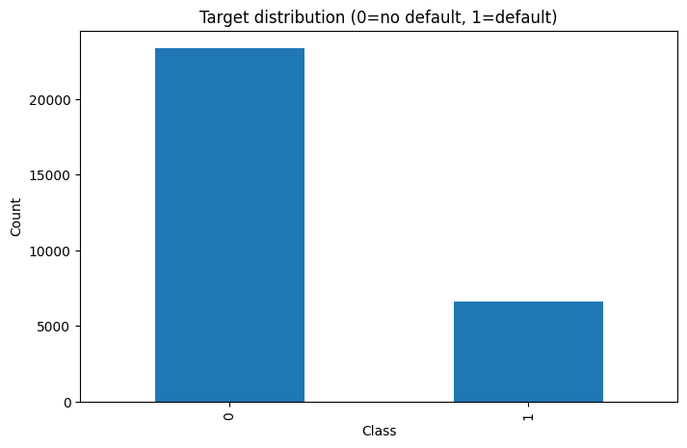
Figure 1: Distribution of default and non-default cases
This figure highlights that non-default cases significantly outnumber default cases, confirming the imbalanced nature of the classification task. This observation motivated the use of imbalance-aware evaluation metrics and modelling strategies in subsequent stages.
3.4 Data Cleaning and Recoding
Several variables in the dataset required cleaning to ensure consistency with their documented definitions:
- EDUCATION: Values outside the recognised categories were grouped into a single “other” category.
- MARRIAGE: Invalid category values were reassigned to a consolidated category.
- SEX: Encoded values were validated to ensure consistency.
- Repayment status variables (PAY_0 to PAY_6): Extreme or undocumented delay values were capped to reduce noise and stabilise model training.
These cleaning steps reduce the impact of data inconsistencies and ensure that the features represent meaningful customer characteristics.
3.5 Exploratory Analysis of Categorical Variables
To gain insight into how default behaviour varies across customer groups, default rates were analysed for key categorical variables.
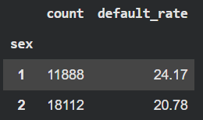
Figure 2: Default rate by gender
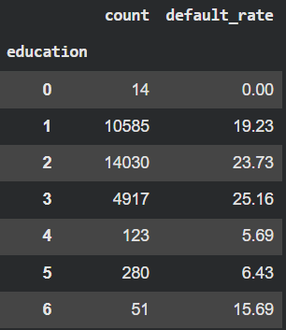
Figure 3: Default rate by education level
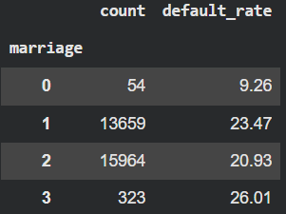
Figure 4: Default rate by marital status
These visualisations provide an early understanding of how demographic factors relate to default risk, without drawing predictive conclusions at this stage.
3.6 Feature Representation and Scaling
The dataset contains a combination of demographic attributes, repayment history indicators, billing amounts, and payment amounts. Continuous numeric features were retained to preserve information content.
For models sensitive to feature scaling, standardisation was applied using a pipeline-based approach to prevent data leakage. Scaling parameters were learned exclusively from the training data and applied consistently to validation and test sets.
3.7 Train–Validation–Test Split
To ensure robust evaluation, the dataset was split into training, validation, and test sets. A stratified splitting strategy was employed to preserve the original class distribution across all subsets.
- The training set was used to fit model parameters.
- The validation set was used for model selection and hyperparameter tuning.
- The test set was reserved exclusively for final evaluation.
This approach prevents information leakage and enables an unbiased assessment of model generalisation.
3.8 Handling Class Imbalance
Given the imbalanced nature of the dataset, class imbalance was addressed at the algorithm level rather than through resampling. This choice preserves the original data distribution, which is important in credit risk modelling.
- For linear models, class-weight balancing was applied to penalise misclassification of default cases.
- For boosting-based models, a positive class weighting factor was used to increase sensitivity to default events.
These strategies allow the models to focus on the minority class while maintaining realistic data characteristics.
CHAPTER - 4
MODELLING
4.1 Overview of the Modelling Pipeline
This project adopts a progressive modelling strategy, beginning with a simple baseline model and advancing towards more complex machine learning and deep learning approaches. This layered approach enables a clear comparison between traditional statistical methods and more advanced models while maintaining interpretability and robustness.
Three primary models are implemented:
- Logistic Regression as a baseline model
- Gradient Boosting using XGBoost
- A deep learning model based on a Gated Recurrent Unit (GRU)
In addition, probability calibration and cost-sensitive decision policies are incorporated to ensure that model outputs are suitable for real-world credit risk decision-making.
4.2 Baseline Model: Logistic Regression
Logistic Regression is used as a baseline due to its widespread adoption in credit scoring and its interpretability. The model estimates the probability of default as a function of input features using a linear decision boundary.
To ensure consistent preprocessing and prevent data leakage, Logistic Regression was implemented using a pipeline-based approach that includes feature standardisation. Given the imbalanced nature of the dataset, class weights were adjusted to penalise misclassification of default cases more heavily.
This baseline model provides a reference point against which the performance of more complex models can be evaluated.
4.3 Gradient Boosting Model: XGBoost
To capture non-linear relationships and feature interactions, a gradient boosting model was implemented using XGBoost. Boosting-based models have been shown to perform well in credit risk prediction due to their ability to model complex patterns in structured data.
A limited set of hyperparameters, including tree depth, learning rate, and number of estimators, was explored using the validation set. Model selection was guided by evaluation metrics suitable for imbalanced classification rather than accuracy alone.
Class imbalance was addressed by adjusting the positive class weighting parameter, increasing the penalty for misclassifying default cases.

4.4 Probability Calibration
Although advanced models often achieve strong discriminative performance, their predicted probabilities may be poorly calibrated. To address this, post-hoc probability calibration was applied to selected models.
Isotonic regression was used to recalibrate predicted probabilities using validation data. This calibration step ensures that predicted default probabilities more accurately reflect observed default frequencies, which is essential for downstream decision-making.
Both machine learning and deep learning model outputs were calibrated before applying decision thresholds.
4.5 Deep Learning Model: GRU-Based Architecture
To explore whether temporal patterns in repayment behaviour improve predictive performance, a deep learning model based on a Gated Recurrent Unit (GRU) architecture was implemented.
Repayment-related features were transformed into fixed-length sequences, allowing the model to learn temporal dependencies across multiple time steps. The GRU architecture was selected due to its ability to model sequential data efficiently while mitigating vanishing gradient issues.
The network consists of a recurrent layer followed by dense layers and is trained using a binary cross-entropy loss function. Model training was performed using a validation set to monitor convergence and prevent overfitting.
4.6 Model Training Strategy
All models were trained using the training set and evaluated on the validation set during development. Hyperparameter tuning was conducted manually within a constrained search space to balance performance and computational efficiency.
Early stopping and regularisation techniques were applied where appropriate to reduce overfitting. Final model evaluation was conducted exclusively on the held-out test set to ensure unbiased performance assessment.

CHAPTER - 5
EVALUATION FRAMEWORK AND DECISION POLICY
5.1 Evaluation Strategy
Evaluating credit default prediction models requires careful consideration of both predictive performance and practical decision-making requirements. Due to the imbalanced nature of the dataset, traditional accuracy-based evaluation is insufficient and can lead to misleading conclusions. Therefore, this project adopts an evaluation framework that emphasises ranking quality, class discrimination, and decision usefulness.
All models were evaluated using a held-out test set that was not used during training, hyperparameter tuning, or calibration. This ensures that reported performance reflects true generalisation capability.
5.2 Performance Metrics
Multiple complementary metrics were used to evaluate model performance:
- Receiver Operating Characteristic Area Under the Curve (ROC-AUC)
ROC-AUC measures the ability of a model to rank default cases higher than non-default cases across all possible thresholds. It is threshold-independent and widely used in credit risk modelling.
- Precision–Recall Area Under the Curve (PR-AUC)
Given the imbalance in the dataset, PR-AUC was prioritised as it provides a more informative assessment of model performance on the minority (default) class. This metric reflects the trade-off between identifying true defaulters and limiting false alarms (Saito and Rehmsmeier, 2015).
- Confusion Matrix-Based Metrics
Precision, recall, and F1-score were used to evaluate classification performance at selected decision thresholds. These metrics support interpretation of operational trade-offs.
This combination of metrics ensures that both ranking ability and classification effectiveness are captured.
5.3 Probability-Based Evaluation
Rather than relying solely on predicted class labels, this project focuses on predicted probabilities of default. Probability-based evaluation is critical in credit risk applications, as probabilities are directly used in downstream decisions such as credit approval, limit assignment, and risk pricing.
To support reliable probability interpretation, models were evaluated both before and after calibration. This allows assessment of whether probability estimates align with observed default frequencies.
5.4 Cost-Sensitive Decision Policy
In real-world credit risk scenarios, the costs associated with misclassification are asymmetric. Misclassifying a customer who will default (false negative) typically results in greater financial loss than incorrectly flagging a non-defaulter (false positive).
To reflect this asymmetry, a cost-sensitive decision policy was implemented. A cost ratio was defined in which false negatives were penalised more heavily than false positives. Instead of using a fixed probability threshold of 0.5, an optimal threshold was selected by minimising the expected cost under this cost structure.
This approach aligns model predictions with business objectives and ensures that decision-making reflects real financial risk rather than purely statistical performance.
5.5 Threshold Selection Procedure
The threshold selection process involved evaluating model performance across a range of probability thresholds. For each threshold, classification outcomes were computed and associated costs were calculated using the predefined cost ratio.
The threshold that minimised the expected cost on the validation data was selected and then applied consistently to the test set. This procedure ensures that the decision policy is data-driven while avoiding overfitting to test data.

CHAPTER - 6
EXPLAINABILITY
6.1 Importance of Explainability in Credit Risk
Explainability is a critical requirement in credit risk modelling due to regulatory, ethical, and operational considerations. Financial institutions must be able to justify automated decisions and clearly communicate the factors influencing a customer’s risk assessment. Black-box models that lack transparency can undermine trust and are often unsuitable for deployment in regulated environments.
As a result, modern credit risk systems increasingly incorporate explainable machine learning techniques that provide insights into model behaviour while retaining strong predictive performance (Lundberg and Lee, 2017).
6.2 SHAP-Based Explainability Framework
This project employs SHapley Additive exPlanations (SHAP) as the primary explainability framework. SHAP is grounded in cooperative game theory and attributes a prediction to individual feature contributions in a consistent and theoretically justified manner.
SHAP values represent the contribution of each feature to the difference between a model’s prediction and the average prediction across the dataset. Positive SHAP values increase the predicted probability of default, while negative values reduce it.
The SHAP framework is model-agnostic and is particularly well suited for explaining complex machine learning models, including gradient boosting and neural networks.
6.3 Global Model Explainability
Global explainability aims to understand the overall behaviour of a model across the entire dataset. In this project, global explanations were generated by aggregating SHAP values across all observations.
This approach allows identification of the most influential features driving default predictions on average. Global explanations are particularly useful for validating whether the model’s behaviour aligns with domain knowledge and established credit risk principles.
Global SHAP visualisations were generated for the trained models to assess feature importance at a dataset level.
6.4 Local Model Explainability
In addition to global insights, local explainability focuses on understanding individual predictions. Local SHAP explanations were generated to analyse how specific features contribute to a single customer’s predicted default probability.
This form of explanation is essential for case-by-case decision analysis, such as manual credit reviews or customer-level justifications. Local explanations enable stakeholders to identify the key risk drivers behind individual predictions and support transparency in automated decision-making.
6.5 Explainability Across Models
SHAP-based explanations were applied to selected models in this project to ensure interpretability across different modelling approaches. By using a consistent explainability framework, comparisons between models remain meaningful and coherent.
This approach ensures that improvements in predictive performance do not come at the expense of interpretability, which is a key requirement in credit risk applications.

CHAPTER - 7
RESULTS
7.1 Overview of Experimental Results
This chapter presents results for the implemented models using the evaluation framework described in Chapter 5. Since the dataset is imbalanced, emphasis is placed on PR-AUC (Average Precision) alongside ROC-AUC, and the operational behaviour of the models is assessed using a cost-sensitive thresholding policy. In addition, probability calibration is evaluated using calibration plots and calibration-oriented scores.
7.2 Baseline Results: Logistic Regression
Logistic Regression is used as a baseline credit scoring model. Its performance is reported using:
- ROC-AUC (computed via roc_auc_score)
- PR-AUC / Average Precision (computed via average_precision_score)
- confusion matrix and classification report at the selected threshold
Model | ROC-AUC | PR-AUC
Logistic | 0.731 | 0.5
Table 3: ROC and PR values for Logistic Regression
From Table, the ROC-AUC indicates that the baseline model is able to distinguish defaulters from non-defaulters better than random classification. However, the PR-AUC value is noticeably lower, reflecting limited effectiveness in identifying the minority default class.
7.3 XGBoost Results (Uncalibrated)
XGBoost is evaluated next to capture non-linear relationships and feature interactions. As implemented in your notebook, the model explicitly addresses class imbalance using a positive-class weighting strategy.
Model | ROC-AUC | PR-AUC
Logistic | 0.731 | 0.5
Table 4: ROC and PR values for XGBoost (Uncalibrated)
The improvement in PR-AUC is particularly important, as it indicates better ranking of default cases within the imbalanced dataset. This suggests that XGBoost is more effective at identifying high-risk customers, likely due to its ability to model non-linear relationships and feature interactions.

7.4 Probability Calibration Results (Isotonic Calibration)
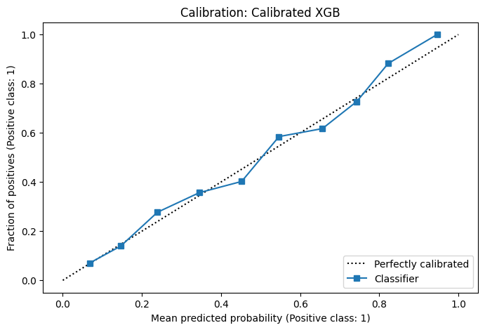
Figure 5: Calibration curve for calibrated XGBoost
Model | ROC-AUC | PR-AUC | Brier Score
Calibrated XGB | 0.776 | 0.554 | 0.1355
Table 5: ROC, PR and brier score values for XGBoost (Calibrated)
Figure 5 presents the calibration curve for the XGBoost model before and after isotonic calibration. Before calibration, the predicted probabilities deviate from the ideal diagonal line, indicating overconfidence in certain probability ranges. After calibration, the predicted probabilities align more closely with the observed default frequencies. This improvement is quantitatively supported by the reduction in Brier score, as reported in Table 5.
Importantly, calibration does not materially degrade ROC-AUC or PR-AUC, confirming that probability reliability can be improved without sacrificing discriminative performance. This is particularly relevant for credit risk applications where probabilities are used directly in decision-making.

7.5 Cost-Sensitive Threshold Tuning Results
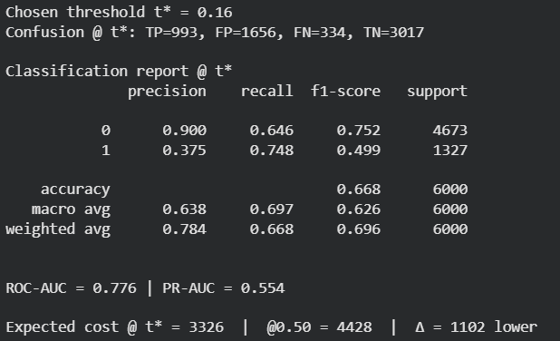
Figure 6: Cost-Sensitive Threshold Tuning Results
Rather than applying a fixed probability threshold of 0.5, a cost-sensitive threshold was selected based on a false-negative–to–false-positive cost ratio of 5:1. Figure 6 reports the selected optimal threshold along with the associated expected cost. When compared with the default threshold of 0.5, the chosen threshold results in a lower overall expected cost, despite increasing the number of false positives.
The confusion matrix shows that this threshold substantially increases recall for defaulters, reducing the number of missed defaults. This shift reflects a deliberate prioritisation of default detection over strict precision, which is appropriate in credit risk contexts where missed defaults are more costly than false alarms.
7.6 Explainability Results (SHAP)
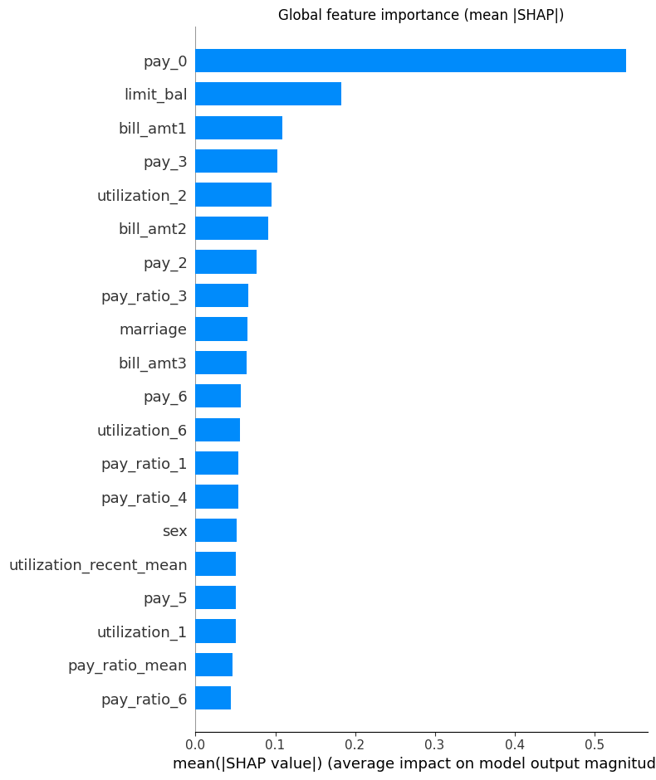
Figure 7: Global feature importance (mean |SHAP| bar plot)
Figure 7 presents the global SHAP feature importance plot. Repayment-related variables and recent payment behaviour emerge as the most influential drivers of default risk, indicating that the model places greater emphasis on behavioural patterns rather than static demographic attributes.
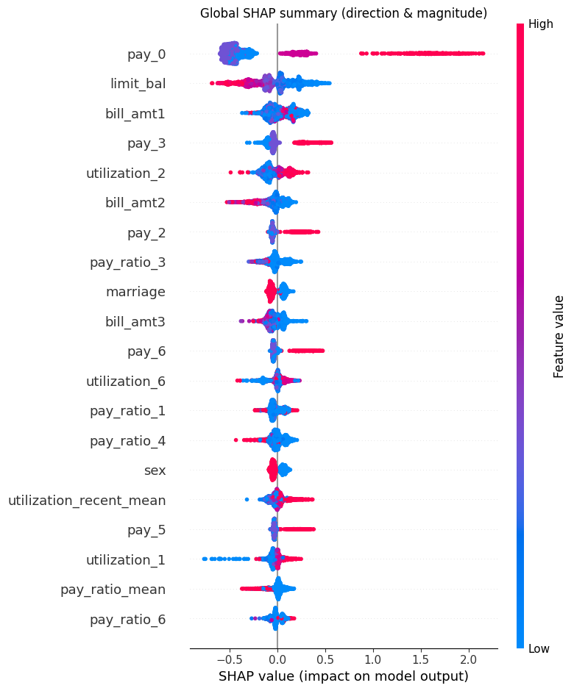
Figure 8: SHAP summary plot
The SHAP summary plot in Figure 8 further illustrates the directionality of feature effects. Higher repayment delays and larger outstanding balances consistently push predictions towards default, while timely payments reduce predicted risk.
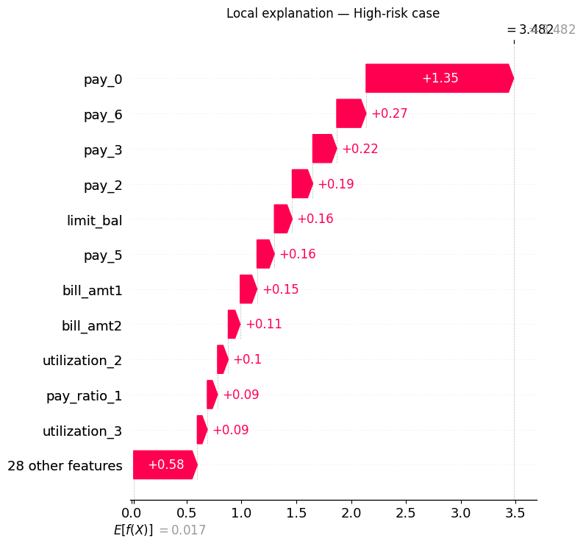
Figure 9: Local SHAP waterfall – high-risk case
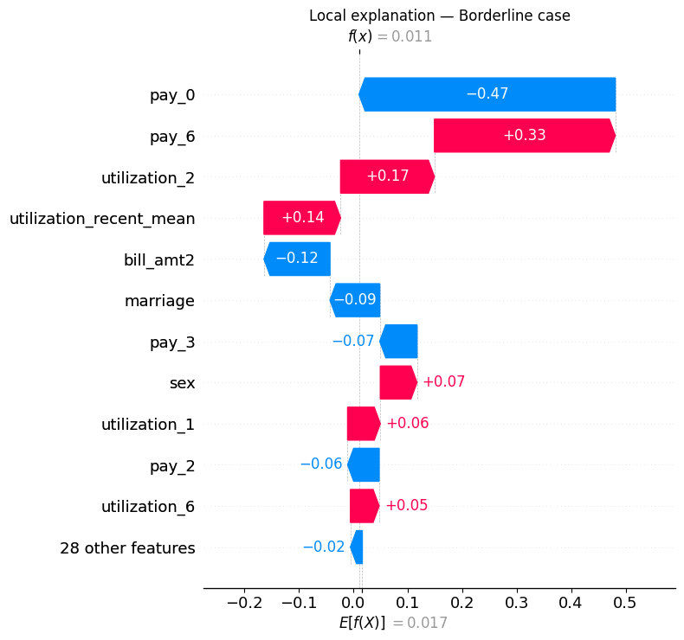
Figure 10: Local SHAP waterfall – borderline case
Local SHAP waterfall plots shown in Figures 9 and 10 provide case-level explanations. In high-risk cases, repayment status variables dominate the prediction, whereas borderline cases exhibit a balance between risk-increasing and risk-decreasing factors. These plots demonstrate how individual features combine to produce final model decisions, supporting transparency and interpretability.
7.7 Comparative Discussion
Across all models, XGBoost combined with probability calibration and cost-sensitive thresholding delivers the strongest overall performance. While the GRU model captures temporal information, its performance gains over XGBoost are limited, suggesting that the structured tabular features already capture most of the predictive signal in this dataset.
The results highlight that improvements in credit risk prediction are not driven solely by model complexity, but by careful integration of calibration, evaluation metrics, and decision policies.

CHAPTER - 8
CONCLUSION AND FUTURE WORK
8.1 Conclusion
This project addressed the problem of credit card default prediction using an imbalanced real-world dataset, with an emphasis on producing models that are accurate, reliable, and suitable for practical decision-making. A baseline Logistic Regression model provided an interpretable reference but showed limited ability to identify default cases.
Advanced machine learning models, particularly XGBoost, demonstrated improved performance in ranking defaulters, as reflected by higher PR-AUC values. Probability calibration using isotonic regression significantly improved the reliability of predicted default probabilities, making the model outputs more appropriate for operational use.
A cost-sensitive decision threshold was implemented to reflect asymmetric misclassification costs. This approach reduced overall expected cost and improved detection of default cases compared to a fixed threshold strategy. SHAP-based explainability further enhanced transparency by identifying key drivers of default risk at both global and individual levels.
Overall, the results demonstrate that integrating calibration, cost-aware decision policies, and explainability with machine learning models leads to a more robust and practically usable credit risk prediction framework.

8.2 Limitations
Despite the strengths of this study, several limitations should be acknowledged. First, the dataset represents a specific population and time period, which may limit the generalisability of the findings to other credit portfolios. Second, temporal dynamics were explored using a GRU-based model; however, the performance gains over tree-based models were modest, suggesting that the sequential representation could be further refined. Additionally, hyperparameter tuning was conducted within a constrained search space due to computational considerations, which may have limited the achievable performance.
8.3 Future Work
Several avenues for future research emerge from this work. More extensive hyperparameter optimisation could be performed to further improve model performance. Alternative calibration techniques, such as Platt scaling or Bayesian calibration methods, could be explored and compared. Future studies may also investigate alternative cost structures that reflect different business objectives or risk appetites.
In addition, incorporating external or longitudinal data sources could enhance temporal modelling and improve default prediction. Further development of explainability techniques, including counterfactual explanations, could provide even more actionable insights for decision-makers. Finally, validating the proposed framework on additional credit datasets would help assess its robustness and general applicability.

REFERENCES
Bahnsen, A.C., Aouada, D. and Ottersten, B. (2015) ‘Example-dependent cost-sensitive decision trees’, Expert Systems with Applications, 42(19), pp. 6609–6619.
(Available at: https://doi.org/10.1016/j.eswa.2015.04.042)
Elkan, C. (2001) ‘The foundations of cost-sensitive learning’, in Proceedings of the 17th International Joint Conference on Artificial Intelligence (IJCAI), Seattle, USA, pp. 973–978.
(Available at: https://cseweb.ucsd.edu/~elkan/rescale.pdf)
He, H. and Garcia, E.A. (2009) ‘Learning from imbalanced data’, IEEE Transactions on Knowledge and Data Engineering, 21(9), pp. 1263–1284.
(Available at: https://doi.org/10.1109/TKDE.2008.239)
Kull, M., Silva Filho, T.M. and Flach, P. (2017) ‘Beta calibration: a well-founded and easily implemented improvement on logistic calibration for binary classifiers’, Proceedings of the 20th International Conference on Artificial Intelligence and Statistics (AISTATS), pp. 623–631.
(Available at: http://proceedings.mlr.press/v54/kull17a.html)
Lessmann, S., Baesens, B., Seow, H.-V. and Thomas, L.C. (2015) ‘Benchmarking state-of-the-art classification algorithms for credit scoring: an update of research’, European Journal of Operational Research, 247(1), pp. 124–136.
(Available at: https://doi.org/10.1016/j.ejor.2015.05.030)
Lundberg, S.M. and Lee, S.-I. (2017) ‘A unified approach to interpreting model predictions’, Advances in Neural Information Processing Systems, 30, pp. 4765–4774.
(Available at: https://proceedings.neurips.cc/paper/2017/file/8a20a8621978632d76c43dfd28b67767-Paper.pdf)
Niculescu-Mizil, A. and Caruana, R. (2005) ‘Predicting good probabilities with supervised learning’, Proceedings of the 22nd International Conference on Machine Learning (ICML), pp. 625–632.
(Available at: https://doi.org/10.1145/1102351.1102430)
Saito, T. and Rehmsmeier, M. (2015) ‘The precision–recall plot is more informative than the ROC plot when evaluating binary classifiers on imbalanced datasets’, PLOS ONE, 10(3), e0118432.
(Available at: https://doi.org/10.1371/journal.pone.0118432)
Sirignano, J., Sadhwani, A. and Giesecke, K. (2018) ‘Deep learning for mortgage risk’, arXiv preprint, arXiv:1607.02470.
(Available at: https://arxiv.org/abs/1607.02470)
Wang, Z., Jiang, C., Li, Z. and Chen, S. (2018) ‘Sequential credit risk modeling using recurrent neural networks’, IEEE Access, 6, pp. 31711–31719.
(Available at: https://www.researchgate.net/publication/323130907_Credit_Risk_Assessment_Algorithm_Using_Deep_Neural_Networks_with_Clustering_and_Merging)
Yeh, I.-C. and Lien, C.-H. (2009) ‘The comparisons of data mining techniques for the predictive accuracy of probability of default of credit card clients’, Expert Systems with Applications, 36(2), pp. 2473–2480.
(Available at: https://doi.org/10.1016/j.eswa.2007.12.020)

APPENDIX
# %%
import numpy as np
import pandas as pd
import matplotlib.pyplot as plt
from sklearn.model_selection import train_test_split
from sklearn.preprocessing import StandardScaler
from sklearn.pipeline import Pipeline
from sklearn.compose import ColumnTransformer
from sklearn.metrics import (
roc_auc_score, average_precision_score, precision_recall_curve,
confusion_matrix, classification_report, brier_score_loss
)
from sklearn.linear_model import LogisticRegression
from sklearn.calibration import CalibratedClassifierCV
from xgboost import XGBClassifier
import warnings; warnings.filterwarnings("ignore")

# %%
# Mount the Google Drive
from google.colab import drive
drive.mount('/content/drive')

# %%
pd.set_option("display.max_columns", 200)
plt.rcParams["figure.figsize"] = (8,5)
RANDOM_STATE = 42

# %%
# Load data
df = pd.read_excel("/content/drive/MyDrive/Durga Project /default of credit card clients.xlsx", skiprows=1)
df.head()

# %%
# make column names simple: lowercase + underscores
df.columns = [str(c).strip().replace('.', '_').replace(' ', '_').lower() for c in df.columns]

# %%
df.head()

# %%
# standardize target name to `default_payment_next_month`
if 'default_payment_next_month' not in df.columns:
for cand in ['default.payment.next.month','default payment next month','y','default']:
key = cand.replace('.', '_').replace(' ', '_').lower()
if key in df.columns:
df.rename(columns={key:'default_payment_next_month'}, inplace=True)
break
df.head()

# %%
if "id" in df.columns:
df.drop(columns="id", inplace=True)
df.head()

# %%
print("Shape:", df.shape)

# %%
print("\nFirst 10 columns:", df.columns.tolist()[:10])

# %%
print("\nTarget counts:")
print(df['default_payment_next_month'].value_counts(dropna=False))

# %%
df.isna().sum().sort_values(ascending=False)

# %%
t = df['default_payment_next_month']
fig, ax = plt.subplots()
t.value_counts().sort_index().plot(kind='bar', ax=ax)
ax.set_title("Target distribution (0=no default, 1=default)")
ax.set_xlabel("Class")
ax.set_ylabel("Count")
plt.show()

# %%
# categorical summaries with default rate
def cat_summary(df, col, target='default_payment_next_month'):
g = df.groupby(col)[target].agg(['count','mean']).rename(columns={'mean':'default_rate'})
g['default_rate'] = (g['default_rate']*100).round(2)
return g.sort_index()

for col in ['sex','education','marriage']:
if col in df.columns:
display(cat_summary(df, col))

# %%
# numeric histograms
for col in ['limit_bal','age']:
if col in df.columns:
df[col].hist(bins=30)
plt.title(f"{col} distribution")
plt.xlabel(col); plt.ylabel("count")
plt.show()

# %%
# Convert target to numeric for correlation
y = df['default_payment_next_month'].astype(float)

num_cols = [c for c in df.columns if c not in ['default_payment_next_month'] and df[c].dtype != 'O']
corr = df[num_cols].corr()
corr.head(10)

# %%
dfc = df.copy()

# %%
# Clean categorical codes
# EDUCATION: valid {1,2,3,4}. Map {0,5,6} -> 4 ("others")
if 'education' in dfc.columns:
dfc['education'] = pd.to_numeric(dfc['education'], errors='coerce').fillna(4).astype(int)
dfc['education'] = dfc['education'].replace({0:4, 5:4, 6:4})

# MARRIAGE: valid {1,2,3}. Map 0 -> 3 ("others")
if 'marriage' in dfc.columns:
dfc['marriage'] = pd.to_numeric(dfc['marriage'], errors='coerce').fillna(3).astype(int)
dfc['marriage'] = dfc['marriage'].replace({0:3})

# SEX should be {1,2}
if 'sex' in dfc.columns:
dfc['sex'] = pd.to_numeric(dfc['sex'], errors='coerce').fillna(2).astype(int)

# PAY_* are ordinal delinquency codes; clip to [-1, 9]
pay_cols = sorted([c for c in dfc.columns if c.startswith('pay_')],
key=lambda x: int(x.split('_')[1]) if x.split('_')[1].isdigit() else 999)
for c in pay_cols:
dfc[c] = pd.to_numeric(dfc[c], errors='coerce').fillna(0).astype(int)
dfc[c] = dfc[c].clip(lower=-1, upper=9)

# %%
# Feature engineering
# Utilization per month: bill_amtk / limit_bal
if 'limit_bal' in dfc.columns:
for k in range(1, 7):
b = f'bill_amt{k}'
if b in dfc.columns:
dfc[f'utilization_{k}'] = dfc[b] / dfc['limit_bal'].replace(0, np.nan)
dfc[f'utilization_{k}'] = dfc[f'utilization_{k}'].fillna(0.0)

# Payment ratio per month: pay_amtk / |bill_amtk|
for k in range(1, 7):
p = f'pay_amt{k}'
b = f'bill_amt{k}'
if p in dfc.columns and b in dfc.columns:
denom = (dfc[b].abs() + 1e-6) # safe divide
dfc[f'pay_ratio_{k}'] = dfc[p] / denom

# Aggregates that capture recent behavior
util_cols = [c for c in dfc.columns if c.startswith('utilization_')]
payr_cols = [c for c in dfc.columns if c.startswith('pay_ratio_')]

if util_cols:
dfc['utilization_mean'] = dfc[util_cols].mean(axis=1)
dfc['utilization_recent_mean'] = dfc[[c for c in util_cols if c.endswith('1') or c.endswith('2')]].mean(axis=1)

if payr_cols:
dfc['pay_ratio_mean'] = dfc[payr_cols].mean(axis=1)
dfc['pay_ratio_recent_mean'] = dfc[[c for c in payr_cols if c.endswith('1') or c.endswith('2')]].mean(axis=1)

# %%
# Quick preview & hand-off
target = 'default_payment_next_month'
new_cols = [c for c in ['utilization_recent_mean','pay_ratio_recent_mean',
'utilization_1','utilization_2','pay_ratio_1','pay_ratio_2'] if c in dfc.columns]

print("New feature samples:")
display(dfc[new_cols].head(5))

print("\nPAY_* columns clipped to range [-1,9]:")
print({c: (int(dfc[c].min()), int(dfc[c].max())) for c in pay_cols})

print("\nShape after feature engineering:", dfc.shape)

# Replace df with cleaned+featured version for next steps
df = dfc

# %%
df.head()

# %%
target = 'default_payment_next_month'
X = df.drop(columns=[target])
y = df[target].astype(int)

X_train, X_val, y_train, y_val = train_test_split(
X, y, test_size=0.2, random_state=RANDOM_STATE, stratify=y
)
X_train.shape, X_val.shape

# %%
# numeric columns only (all are numeric in this dataset)
num_cols = X_train.columns.tolist()
num_cols

# %%
# Logistic Regression
preprocess = ColumnTransformer([('num', StandardScaler(), num_cols)], remainder='drop')
log_reg = Pipeline([
('prep', preprocess),
('clf', LogisticRegression(max_iter=1000, class_weight='balanced', random_state=RANDOM_STATE))
])
log_reg.fit(X_train, y_train)
proba_lr = log_reg.predict_proba(X_val)[:,1]
print("Logistic:")
print(f"ROC-AUC={roc_auc_score(y_val, proba_lr):.3f}")
print(f"PR-AUC={average_precision_score(y_val, proba_lr):.3f}")

# %%
# XGBoost (class imbalance handled via scale_pos_weight)
pos_weight = (len(y_train) - y_train.sum()) / y_train.sum()
xgb = XGBClassifier(
n_estimators=400, max_depth=4, learning_rate=0.05,
subsample=0.9, colsample_bytree=0.8,
reg_alpha=0.0, reg_lambda=1.0,
random_state=RANDOM_STATE, n_jobs=-1,
scale_pos_weight=pos_weight
)
xgb.fit(X_train, y_train)
proba_xgb = xgb.predict_proba(X_val)[:,1]
print(f"XGBoost ROC-AUC={roc_auc_score(y_val, proba_xgb):.3f} | PR-AUC={average_precision_score(y_val, proba_xgb):.3f}")

# %%
cal = CalibratedClassifierCV(xgb, method='isotonic', cv=3)
cal.fit(X_train, y_train)
proba_cal = cal.predict_proba(X_val)[:,1]

print(f"Calibrated XGB ROC-AUC={roc_auc_score(y_val, proba_cal):.3f} | PR-AUC={average_precision_score(y_val, proba_cal):.3f}")
print(f"Brier score (lower is better) = {brier_score_loss(y_val, proba_cal):.4f}")

# quick reliability curve (optional visualization)
from sklearn.calibration import CalibrationDisplay
disp = CalibrationDisplay.from_predictions(y_val, proba_cal, n_bins=10)
plt.title("Calibration: Calibrated XGB")
plt.show()

# %%
def choose_threshold_cost(y_true, y_score, cost_fp=1.0, cost_fn=5.0):
thresholds = np.linspace(0.05, 0.95, 181)
best = None
for t in thresholds:
y_pred = (y_score >= t).astype(int)
tn, fp, fn, tp = confusion_matrix(y_true, y_pred).ravel()
cost = cost_fp*fp + cost_fn*fn
if (best is None) or (cost < best[0]):
best = (cost, t, tp, fp, fn, tn)
return best

best_cost, best_t, tp, fp, fn, tn = choose_threshold_cost(y_val, proba_cal, cost_fp=1.0, cost_fn=5.0)
print(f"Best threshold = {best_t:.2f} | Min expected cost = {best_cost}")
print(f"Confusion @t: TP={tp}, FP={fp}, FN={fn}, TN={tn}")

y_pred_best = (proba_cal >= best_t).astype(int)
print("\nClassification report @ best threshold:")
print(classification_report(y_val, y_pred_best, digits=3))

# %%
# SHAP global explanation
import shap

# Use calibrated probabilities
y_score = proba_cal if 'proba_cal' in globals() else proba_xgb

# Subsample validation for speed
rng = np.random.default_rng(42)
idx = rng.choice(len(X_val), size=min(2000, len(X_val)), replace=False)
Xv = X_val.iloc[idx]

explainer = shap.TreeExplainer(xgb)
shap_values = explainer.shap_values(Xv)

# %%
# Mean |SHAP| (bar) — easiest to present
shap.summary_plot(shap_values, Xv, plot_type='bar', show=False)
plt.title("Global feature importance (mean |SHAP|)")
plt.tight_layout()
plt.show()

# %%
# Dot summary — shows direction
shap.summary_plot(shap_values, Xv, show=False)
plt.title("Global SHAP summary (direction & magnitude)")
plt.tight_layout()
plt.show()

# %%
# computed best_t for cost-aware threshold else 0.50
best_t = best_t if 'best_t' in globals() else 0.50
y_score_full = y_score

# Pick one highest-risk case and one near the decision threshold
hi_i = int(np.argmax(y_score_full))
bd_i = int(np.argmin(np.abs(y_score_full - best_t)))

row_hi = X_val.iloc[[hi_i]]
row_bd = X_val.iloc[[bd_i]]

# Ensure columns match explainer expectation
row_hi = row_hi[Xv.columns]
row_bd = row_bd[Xv.columns]

# Compute SHAP for each row
sv_hi = explainer.shap_values(row_hi)
sv_bd = explainer.shap_values(row_bd)

# %%
# Waterfall plots
shap.plots._waterfall.waterfall_legacy(explainer.expected_value, sv_hi[0], feature_names=row_hi.columns, max_display=12, show=False)
plt.title("Local explanation — High-risk case")
plt.tight_layout()
plt.show()

# %%
shap.plots._waterfall.waterfall_legacy(explainer.expected_value, sv_bd[0], feature_names=row_bd.columns, max_display=12, show=False)
plt.title("Local explanation — Borderline case")
plt.tight_layout()
plt.show()

# %%
from sklearn.metrics import confusion_matrix, classification_report, precision_recall_curve, average_precision_score, roc_auc_score

# Use calibrated probs
y_score = proba_cal if 'proba_cal' in globals() else proba_xgb
y_true = y_val.values

# Set costs
COST_FP, COST_FN = 1.0, 5.0

ths = np.linspace(0.01, 0.99, 199)
costs, cms = [], []
for t in ths:
y_pred = (y_score >= t).astype(int)
tn, fp, fn, tp = confusion_matrix(y_true, y_pred).ravel()
costs.append(COST_FP*fp + COST_FN*fn)
cms.append((tn, fp, fn, tp))

best_i = int(np.argmin(costs))
best_t = float(ths[best_i])
tn, fp, fn, tp = cms[best_i]
y_pred_best = (y_score >= best_t).astype(int)

print(f"Chosen threshold t* = {best_t:.2f}")
print(f"Confusion @ t*: TP={tp}, FP={fp}, FN={fn}, TN={tn}")
print("\nClassification report @ t*")
print(classification_report(y_true, y_pred_best, digits=3))

ap = average_precision_score(y_true, y_score)
roc = roc_auc_score(y_true, y_score)
print(f"\nROC-AUC = {roc:.3f} | PR-AUC = {ap:.3f}")

# For context vs naive 0.50
tn05, fp05, fn05, tp05 = confusion_matrix(y_true, (y_score>=0.50).astype(int)).ravel()
cost_best = COST_FP*fp + COST_FN*fn
cost_05 = COST_FP*fp05 + COST_FN*fn05
print(f"\nExpected cost @ t* = {cost_best:.0f} | @0.50 = {cost_05:.0f} | Δ = {cost_05 - cost_best:.0f} lower")

# %%
# Build (N, 6, F) sequences for GRU

import numpy as np
import pandas as pd
from sklearn.preprocessing import StandardScaler

# Define the monthly feature columns
def month_cols(k):
# k: 1..6
b = f"bill_amt{k}"
p = f"pay_amt{k}"
u = f"utilization_{k}"
r = f"pay_ratio_{k}"
# delinquency code: month1 uses pay_0, months 2..6 use pay_2..pay_6
if k == 1:
d = "pay_0"
else:
d = f"pay_{k if k>=2 else 2}" # k=2→pay_2 ... k=6→pay_6
return [b, p, d, u, r]

seq_cols = [c for k in range(1,7) for c in month_cols(k)]
seq_cols = [c for c in seq_cols if c in df.columns] # keep only existing

# Helper to stack months into (N,6,F)
def make_sequences(frame):
# frame: DataFrame indexed to the rows we want (e.g., df.loc[X_train.index])
# Build per-month tensors and stack on time axis
month_tensors = []
for k in range(1,7):
cols = [c for c in month_cols(k) if c in frame.columns]
M = frame[cols].copy()
# ensure all numeric
for c in cols:
M[c] = pd.to_numeric(M[c], errors='coerce').fillna(0.0)
month_tensors.append(M.values)
# shape per month: (N, F_k). We need same F each month; pad if needed.
maxF = max(m.shape[1] for m in month_tensors)
padded = []
for M in month_tensors:
if M.shape[1] < maxF:
pad = np.zeros((M.shape[0], maxF - M.shape[1]), dtype=float)
M = np.hstack([M, pad])
padded.append(M)
# stack months into time axis: list length 6 -> (6, N, F) -> transpose to (N,6,F)
X_seq = np.stack(padded, axis=1) # (N, 6, F)
return X_seq

# Build train/val sequences matching your existing split
X_train_seq = make_sequences(df.loc[X_train.index])
X_val_seq = make_sequences(df.loc[X_val.index])

# Standardize features across the training set (flatten -> scale -> reshape)
Ntr, T, F = X_train_seq.shape
scaler = StandardScaler()
X_train_seq_2d = X_train_seq.reshape(Ntr, T*F)
X_train_seq_2d = scaler.fit_transform(X_train_seq_2d)
X_train_seq = X_train_seq_2d.reshape(Ntr, T, F)

Nva = X_val_seq.shape[0]
X_val_seq_2d = X_val_seq.reshape(Nva, T*F)
X_val_seq_2d = scaler.transform(X_val_seq_2d)
X_val_seq = X_val_seq_2d.reshape(Nva, T, F)

print("Sequence shapes — train:", X_train_seq.shape, " val:", X_val_seq.shape)

# %%
# Train a compact GRU model

import numpy as np, tensorflow as tf
from tensorflow import keras
from tensorflow.keras import layers

# Class weights (same idea as scale_pos_weight)
pos = int(y_train.sum()); neg = int(len(y_train) - pos)
class_weight = {0: 1.0, 1: max(1.0, neg/pos)}

# Model
tf.keras.backend.clear_session()
model = keras.Sequential([
layers.Input(shape=(X_train_seq.shape[1], X_train_seq.shape[2])),
layers.GRU(32, return_sequences=False),
layers.Dense(16, activation='relu'),
layers.Dropout(0.3),
layers.Dense(1, activation='sigmoid')
])

model.compile(
optimizer=keras.optimizers.Adam(learning_rate=1e-3),
loss='binary_crossentropy',
metrics=[keras.metrics.AUC(name='auc_roc'),
keras.metrics.AUC(name='auc_pr', curve='PR')]
)

cb = [
keras.callbacks.EarlyStopping(monitor='val_auc_pr', mode='max',
patience=5, restore_best_weights=True)
]

hist = model.fit(
X_train_seq, y_train.values,
validation_data=(X_val_seq, y_val.values),
epochs=30, batch_size=256,
class_weight=class_weight,
callbacks=cb, verbose=1
)

# Predicted probabilities on validation
proba_gru = model.predict(X_val_seq, batch_size=512).ravel()

# %%
from sklearn.metrics import roc_auc_score, average_precision_score

# Prefer calibrated XGB if available
xgb_scores = proba_cal if 'proba_cal' in globals() else proba_xgb

print("Validation metrics")
print(f"XGBoost ROC-AUC={roc_auc_score(y_val, xgb_scores):.3f} | PR-AUC={average_precision_score(y_val, xgb_scores):.3f}")
print(f"GRU ROC-AUC={roc_auc_score(y_val, proba_gru):.3f} | PR-AUC={average_precision_score(y_val, proba_gru):.3f}")

# %%
import numpy as np, pandas as pd
from sklearn.metrics import confusion_matrix, average_precision_score, roc_auc_score

y_score = proba_cal if 'proba_cal' in globals() else proba_xgb
ratios = [(3,1),(5,1),(7,1)]

def pick_t(y_true, y_score, C_FN, C_FP):
ths = np.linspace(0.01,0.99,199); best=(None,None)
for t in ths:
y_pred = (y_score>=t).astype(int)
tn,fp,fn,tp = confusion_matrix(y_true,y_pred).ravel()
cost = C_FP*fp + C_FN*fn
if best[0] is None or cost<best[0]: best=(cost,(t,tp,fp,fn,tn))
return best

rows=[]
for C_FN,C_FP in ratios:
cost,(t,tp,fp,fn,tn)=pick_t(y_val.values,y_score,C_FN,C_FP)
prec = tp/(tp+fp+1e-9); rec = tp/(tp+fn+1e-9)
rows.append([f"{C_FN}:{C_FP}", round(t,2), round(prec,3), round(rec,3), int(cost), tp, fp, fn, tn])

print(pd.DataFrame(rows, columns=["FN:FP","t*","Precision","Recall","Cost","TP","FP","FN","TN"]))
print(f"\nROC-AUC={roc_auc_score(y_val,y_score):.3f} | PR-AUC={average_precision_score(y_val,y_score):.3f}")

# %%
from sklearn.metrics import roc_auc_score, average_precision_score
import pandas as pd

def slice_table(group_col):
tmp = X_val.copy()
tmp[group_col] = df.loc[X_val.index, group_col]
tmp['y'] = y_val.values; tmp['p'] = y_score
rows=[]
for g,sub in tmp.groupby(group_col):
if len(sub)<30: continue
rows.append([g, len(sub),
roc_auc_score(sub['y'], sub['p']),
average_precision_score(sub['y'], sub['p'])])
return pd.DataFrame(rows, columns=[group_col,'n','ROC_AUC','PR_AUC']).sort_values(group_col)

for col in ['sex','education','marriage']:
if col in df.columns:
print(f"\n{col.upper()}")
display(slice_table(col))

# %%
from sklearn.metrics import roc_auc_score, average_precision_score
import numpy as np

base_roc = roc_auc_score(y_val, y_score); base_pr = average_precision_score(y_val, y_score)

cols = [c for c in X_val.columns if c.startswith('bill_amt') or c.startswith('pay_amt')]
Xc = X_val.copy()
rng = np.random.default_rng(0)
for c in cols:
mask = rng.random(len(Xc)) < 0.10
Xc.loc[mask, c] = np.nan
Xc = Xc.fillna(X_train.mean(numeric_only=True))

scores_stress = (cal.predict_proba(Xc)[:,1]) if 'cal' in globals() else xgb.predict_proba(Xc)[:,1]
print(f"Baseline ROC/PR: {base_roc:.3f} / {base_pr:.3f}")
print(f"Stress10% ROC/PR: {roc_auc_score(y_val, scores_stress):.3f} / {average_precision_score(y_val, scores_stress):.3f}")

# %%
# Isotonic calibration for GRU on a small calibration split from TRAIN
from sklearn.isotonic import IsotonicRegression
from sklearn.model_selection import train_test_split
from sklearn.metrics import roc_auc_score, average_precision_score, confusion_matrix
import numpy as np, pandas as pd

# Use the GRU you trained: proba_gru on X_val_seq
# Build a calibration split from TRAIN sequences
X_tr_cal, X_te_cal, y_tr_cal, y_te_cal = train_test_split(X_train_seq, y_train.values, test_size=0.2, random_state=42, stratify=y_train)

proba_gru_tr = model.predict(X_tr_cal, batch_size=512).ravel()
proba_gru_te = model.predict(X_te_cal, batch_size=512).ravel()

iso = IsotonicRegression(out_of_bounds='clip')
iso.fit(proba_gru_tr, y_tr_cal)

proba_gru_cal = iso.transform(model.predict(X_val_seq, batch_size=512).ravel())

# Choose t* for GRU at FN:FP = 5:1 (same policy)
def best_threshold(y_true, y_score, C_FN=5.0, C_FP=1.0):
ths = np.linspace(0.01,0.99,199); best=(None,None)
for t in ths:
y_pred = (y_score>=t).astype(int)
tn,fp,fn,tp = confusion_matrix(y_true,y_pred).ravel()
cost = C_FP*fp + C_FN*fn
if best[0] is None or cost<best[0]: best=(cost,(t,tp,fp,fn,tn))
return best

cost_xgb,(t_xgb,TP,FP,FN,TN)=best_threshold(y_val.values, (proba_cal if 'proba_cal' in globals() else proba_xgb))
cost_gru,(t_gru,TPg,FPg,FNg,TNg)=best_threshold(y_val.values, proba_gru_cal)

print(f"XGB ROC={roc_auc_score(y_val, (proba_cal if 'proba_cal' in globals() else proba_xgb)):.3f} | PR={average_precision_score(y_val, (proba_cal if 'proba_cal' in globals() else proba_xgb)):.3f} | t*={t_xgb:.2f} | cost={int(cost_xgb)}")
print(f"GRU ROC={roc_auc_score(y_val, proba_gru_cal):.3f} | PR={average_precision_score(y_val, proba_gru_cal):.3f} | t*={t_gru:.2f} | cost={int(cost_gru)}")

# %%
from xgboost import XGBClassifier
from sklearn.metrics import average_precision_score

pos = y_train.sum(); neg = len(y_train)-pos; spw = neg/pos
grid = [
dict(n_estimators=500, max_depth=4, learning_rate=0.05, subsample=0.9, colsample_bytree=0.8),
dict(n_estimators=600, max_depth=4, learning_rate=0.04, subsample=0.9, colsample_bytree=0.8),
dict(n_estimators=400, max_depth=5, learning_rate=0.05, subsample=0.9, colsample_bytree=0.7),
]

best=None
for g in grid:
mdl = XGBClassifier(scale_pos_weight=spw, random_state=42, n_jobs=-1, **g)
mdl.fit(X_train, y_train)
p = mdl.predict_proba(X_val)[:,1]
ap = average_precision_score(y_val, p)
print(g, "PR-AUC=", round(ap,3))
if not best or ap>best[0]: best=(ap, g, mdl, p)

print("\nBest config:", best[1], "PR-AUC=", round(best[0],3))

